**Health impacts of waste incineration**

From Laura Stoll, Public Health, Waltham Forest Council.

A report from the UKHSA ([Health impacts of waste incineration: a systematic review of epidemiological evidence in the UK and EU, following implementation of the Waste Incineration Directive](https://www.gov.uk/government/publications/municipal-waste-incinerators-emissions-impact-on-health/epidemiological-evidence-review-in-the-uk-and-eu-following-implementation-of-the-waste-incineration-directive)) reviewed 12 studies (three from the UK and the remainder from the EU mostly Italy). The studies looked at various health conditions - cancer, pregnancy and adverse birth outcomes, mortality, morbidity and hospital admissions – of people who lived near municipal waste incinerators (MWI).

This systematic review shows that currently there is no clear evidence for associations between exposure to emissions from modern, well-regulated MWI and morbidity, cancers, or adverse birth outcomes, and these incinerators only make a small contribution to local concentrations of air pollutants when compared to other sources of air pollution.

This review supports the current UKHSA opinion statement, which is that modern, well run and regulated municipal waste incinerators are not a significant risk to public health.

Overall, while it is not possible to rule out adverse health effects from MWI completely, any potential effect on people living close by is likely to be very small.

**Asthma data for Waltham Forest**

Data provided by Laura Stoll, Public Health, Waltham Forest Council.

In 2023/24, Waltham Forest reported an asthma prevalence of 5.2% among individuals aged 6 and above, slightly higher than the London average of 4.7% (*Source: OHID Fingertips*).

**Ward data**

|  |  |  |  |
| --- | --- | --- | --- |
| **Ward** | **Estimated Count of** **Patients Living with Asthma Aged 6+** | **GP Registered Population Aged 6+** | **Prevalence (%)** |
| Higham Hill | 874 | 13848 | 6.3% |
| Endlebury | 633 | 10387 | 6.1% |
| Hatch Lane & Highams Park North | 734 | 12076 | 6.1% |
| Larkswood | 917 | 15236 | 6.0% |
| Chingford Green | 642 | 10775 | 6.0% |
| Upper Walthamstow | 571 | 9753 | 5.9% |
| Hale End & Highams Park South | 477 | 8277 | 5.8% |
| Markhouse | 604 | 10517 | 5.7% |
| William Morris | 696 | 12335 | 5.6% |
| Wood Street | 500 | 8978 | 5.6% |
| Valley | 838 | 15057 | 5.6% |
| Hoe Street | 716 | 12969 | 5.5% |
| Forest | 961 | 18533 | 5.2% |
| Cann Hall | 851 | 16446 | 5.2% |
| St James | 720 | 14297 | 5.0% |
| Chapel End | 708 | 14354 | 4.9% |
| Cathall | 503 | 10417 | 4.8% |
| Leyton | 795 | 16561 | 4.8% |
| Lea Bridge | 759 | 16127 | 4.7% |
| High Street | 637 | 14280 | 4.5% |
| Grove Green | 700 | 16423 | 4.3% |
| Leytonstone | 605 | 14316 | 4.2% |
| **Waltham Forest** | **15441** | **291962** | **5.3%** |

*Please note: numbers are estimates, as the patient address identifier was based on the 2011 LSOA code, which is now outdated. Prevalence is crude and has not been age-adjusted.*

*Source: NHS Snowflake database [accessed July 2025]*

**Emergency admission rates**

In 2023/24, Waltham Forest recorded an emergency asthma hospital admission rate of 168.7 per 100,000 for under-19s, higher than the London average of 164.4 and the England average rate. (*Source: OHID Fingertips*).

Waltham Forest was 13th highest out of the 32 London boroughs.

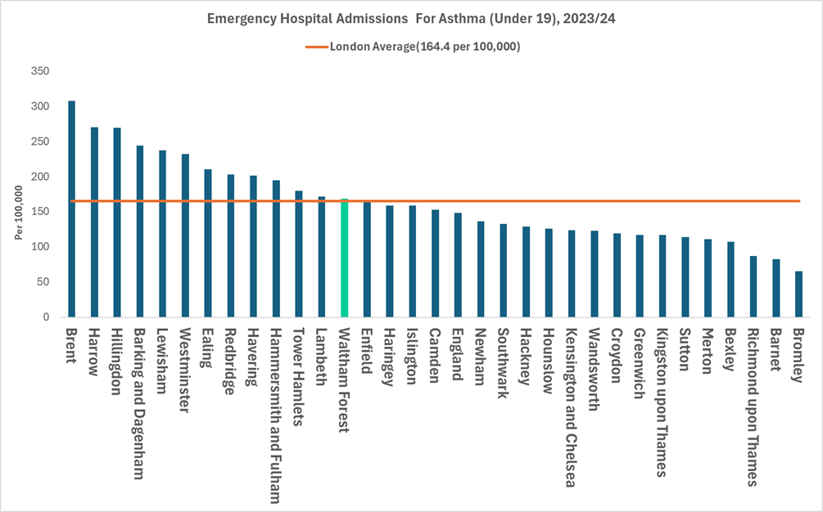

**Asthma prescriptions for under 18s by PCN.**

Between April 2023 and December 2024, asthma prescriptions for patients under 18 in Waltham Forest varied across Primary Care Networks (PCNs). Asthma prescriptions are likely to be influenced by a range of factors including the demographics of the PCN patient population, differences in clinical management, as well as the prevalence of asthma.

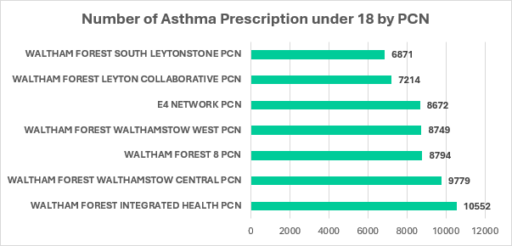

Forest Integrated Health PCN includes GPs that are based in the wards of Cathall, Forest (2), Grove Green (2), Leyton and Leytonstone. All in the south of the borough.