

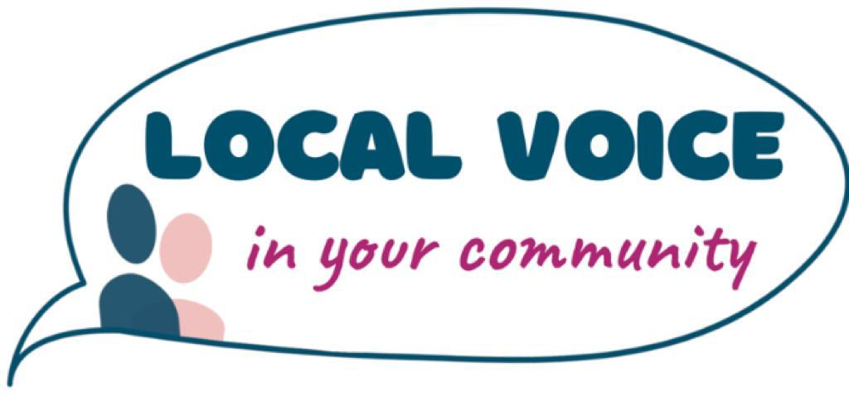
Job Description & Person Specification
Job title | Healthwatch Waltham Forest and Newham Operations Manager
Responsible to | Local Voice Chief Executive

Salary | £32 ,000-£35,000 pa pro rata
Hours | 5 days a week negotiable. Occasional evening and weekend work.
Location | Hybrid across the London Boroughs of Waltham Forest and Newham (desk space available in Newham, with home working)
Contract term | 9-12 months (possible extension subject to funding). This is dependent on the Governments progress on closing Local Healthwatch
Annual leave | 25 days pa (pro rata) and public holidays
Pension | Contributory pension scheme (employer contribution 3% & employee contribution 5%)
DBS | The successful candidate will need to undergo a Disclosure and Barring check

About Healthwatch Waltham Forest and Healthwatch Newham
Healthwatch Waltham Forest and Healthwatch Newham are managed by Local Voice, an independent charity. Each Healthwatch has a statutory duty to ensure that local people have a strong voice in shaping health and social care services. Together, they:
- Promote and support the involvement of local people in the commissioning, provision, and scrutiny of local care services.
- Enable residents to monitor the standard of provision and highlight where services could be improved.
- Gather and represent the views of residents about their needs and experiences.
- Make recommendations for improvements to local health and social care services.
- Provide clear information and signposting to help people access services.
- Escalate concerns to Healthwatch England and the Care Quality Commission where appropriate.

Job Summary
The Operations Manager will manage the day-to-day delivery of both Healthwatch Waltham Forest and Healthwatch Newham. Working closely with Local Voice’s Chief Executive and each borough’s Advisory/Committee structures, the postholder will:
- Ensure high-quality insight gathering, engagement, and reporting to influence change.
- Oversee operational systems, budgets, and governance compliance.
- Lead and support staff and volunteers across both boroughs.
- Deliver annual work programmes based on evidence based co-production and that respond to local needs.
- Build strong relationships with statutory, voluntary, and community stakeholders.
- Contribute to the long-term sustainability of Local Voice and Healthwatch.
Although the primary focus of this role is the operational management of Healthwatch Waltham Forest and Healthwatch Newham, Local Voice also delivers some cross-borough projects involving all three Healthwatch services, including Healthwatch Hammersmith & Fulham. Where these programmes are managed through a single project structure, the postholder may be required to provide operational oversight across all participating boroughs. This will not include any representational or external engagement role for Healthwatch Hammersmith & Fulham, which will remain the responsibility of the designated staff team.

Main duties and responsibilities

Operational management
- Deliver the Healthwatch programmes in both boroughs, ensuring statutory functions are met.
- Manage workplans and priority projects, aligning them to local needs and contracts.
- Provide operational oversight for cross-borough projects delivered jointly across Waltham Forest, Newham and, where applicable, Hammersmith & Fulham, ensuring coordination across teams while excluding any representational duties for Healthwatch Hammersmith & Fulham.
- Lead insight gathering and reporting (including CIS, surveys, outreach, and focus groups).
- Monitor and report against contract requirements for both councils and ICB partners.
- Work with Local Voice’s Finance/HR lead to manage delegated budgets.
- Support the Chief Executive in identifying opportunities for growth and sustainability.

Team working and line management
- Line manage staff, researchers, and volunteers across both boroughs.
- Provide supervision, appraisals, and regular team meetings.
- Support the recruitment and training of Community Insight Researchers and volunteers.
- Foster a positive, inclusive, and supportive team culture.
- Deputise for the Chief Executive as required.

Stakeholder Engagement
- Build credibility and influence with councils, NHS partners, VCSE organisations, and resident groups.
- Represent Healthwatch Waltham Forest and Healthwatch Newham at meetings, boards, and events.
- Support Advisory Groups in setting priorities and monitoring impact.
- Work in partnership with other Healthwatch across North East London on joint projects.

Governance
- Ensure services comply with Healthwatch England guidance, Local Voice policies, and statutory obligations under the Health and Social Care Act 2012.
- Support Advisory Groups in fulfilling their governance responsibilities.
- Work with the Chief Executive and Finance/HR Lead to ensure strong governance structures, policies, and compliance processes are maintained.
- Ensure the service complies with policies regarding equality, diversity, safeguarding, GDPR, and health & safety.
- Contribute to fundraising and sustainability planning to secure the long-term future of Healthwatch services in both boroughs.

Standard responsibilities for all staff
- Promote and raise awareness of Healthwatch and Local Voice.
- Work closely with the Chief Executive and colleagues to share good practice and learning.
- Provide monitoring information as required by commissioners and Healthwatch England.
- Work collaboratively with other Healthwatch organisations where appropriate.
- Undertake reasonable tasks to support the smooth running of the organisation.
- Maintain personal and professional development.
- Act at all times within Local Voice policies and procedures.
- Ensure activities are carried out with due regard to equality and diversity.

Person Specification Person Specification Table
Education | Essential | Desirable
Degree/management qualification or equivalent experience. | E
Evidence of professional development through management training. |  | D
Experience
A minimum of 2 years’ experience of managing teams, budgets, and projects. | E
Working with volunteers and/or community researchers. | E
Partnership working with diverse stakeholders, including service users. | E
Coordinating or overseeing multi-borough or cross-organisation projects within a structured governance framework. |  | D
Using community insights to influence service improvement. | E
Delivering engagement and communications projects. | E
Experience of working with a volunteer board or committee. |  | D
Experience in event management, communications, or consultation. |  | D
Knowledge
Understanding of the health and social care environment and the impact of local, regional, and national policy on residents in London. | E
Awareness of health inequalities and the needs of seldom-heard groups. | E
Principles of consultation, engagement, and co-production. | E
Knowledge of Waltham Forest, Newham and their diverse communities. |  | D
Skills
Strong project management and organisational skills. | E
Excellent communication skills, written and verbal. | E
Confident in presenting to a range of audiences, including strategic boards. | E
Ability to motivate and support staff and volunteers. | E
IT literate (Microsoft Office and digital engagement tools). | E
Ability to manage operational delivery across multiple teams while maintaining clear governance boundaries (e.g., separation of operational and representational responsibilities). |  | D
Personal attributes
Enthusiastic and committed to the values of Healthwatch. | E
Adaptable, proactive, and resilient. | E
Able to work independently and across multiple sites. | E
Committed to equality, diversity, and the Nolan Principles of Public Life. | E
Availability
Ability to travel independently across Waltham Forest, Newham, and beyond. | E

