Enter & View Application Pack
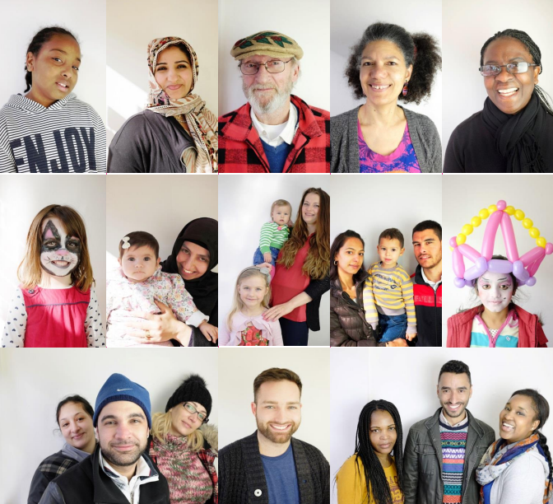

Becoming an
Authorised Representative for Healthwatch Waltham Forest

In this pack you will find:

- Information about Healthwatch Waltham Forest
- Information about the role of an Authorised Representative for Enter and View
- A role description with information about what we will want you to do
- A person specification – the essential criteria of skills, experience and abilities, or knowledge you must show you have to be considered for the role.
- Training information and the expectations we will require from you
- Our Code of Conduct
About Healthwatch Waltham Forest
Healthwatch Waltham Forest is what is known as a ‘local Healthwatch organisation’. Established under the Health and Social Care Act 2012, our role is to act as a local, independent consumer voice for people using health and social care services. Healthwatch Waltham Forest was established in April 2013.

Background
Healthwatch Waltham Forest is the consumer champion for health and social care services in this borough and was established in April 2013. Local Healthwatch’s exist in every local authority area in England, as required by the ‘Health and Social Care Act’ 2012. Our role is to act as a local, independent consumer voice for local people collect/ views and experiences of their services and then to work with service providers to make improvements.

Enter & View
To enable Healthwatch Waltham Forest to gather information about local health and social care services, we use “Authorised Representatives”, to see and hear for themselves how these services are provided.

What does it take to be an Authorised Representative?
You will need to be local to Waltham Forest, or willing to travel, and have some knowledge of health and social care services, either from working or volunteering for them, and/or by personal experience. You will also need a strong desire to work for, connect with and represent the views of users and patients.

Please refer to the list of skills, experience and abilities contained within this pack for more information on what it takes to be an Authorised Representative.

What is Enter and View?
The Enter and View programme is an important part of Healthwatch. Healthwatch representatives can visit and report on sites where health and social care services are offered e.g. hospitals, GP Practices or care homes.

The People We Need
Healthwatch needs people who can talk with users and take note of what is happening in places where problems have been reported, or where examples of interesting or good practice can be made known and publicised.

Healthwatch wants to attract a diverse group of people who would like to work for users and patients in this way, connect with them and represent their views. You will need some knowledge of health and social care services either from work, volunteering, or personal experience. Training and support will be given.

Interviews
Applicants who have been shortlisted will be invited to an interview. This will be a good opportunity for the applicants to find out more about the role and for Healthwatch to assess whether the applicant is suitable for the role.

Training
Applicants will complete the training session (date to be confirmed). And attend refresher sessions with Healthwatch Waltham Forest.

DBS check needed
All successful applicants must undergo a Disclosure and Barring Service (DBS) check and must agree to have their names published as Healthwatch Authorised Representatives.

Expenses and payment
The role is voluntary, but reasonable out of pocket expenses can be claimed, such as travel and lunch etc.

Please return your completed application form to Joyce Osei by email: joyce.osei@healthwatchwalthamforest.co.uk

If you have any support requirements to enable you to apply or require this application pack in an different format please call our office - 0800 145 5026.

The visits
As an Authorised Representative, you will be able to undertake a number of visits throughout the year as part of a team. You will need to attend a briefing meeting before the visit, prepare for your visit, and attend a meeting afterwards to agree with team members on the key points for the written report.

What support do Authorised Representatives receive?
Guidance is available on the role and responsibilities of Authorised Representatives including a code of practice which promotes the importance of good practice and details legal responsibilities. Full training on this and other areas is provided to all Authorised Representatives by way of a training course and ongoing support throughout the role.

Healthwatch Waltham Forest is keen to support their Authorised Representatives. They will assist by drafting the following guides and procedures:

- A guide for preparing for a visit
- A pre-visit checklist
- An explanatory leaflet to leave with providers and users
- A visit template - detailing aims and objectives of the visit
- Reporting, monitoring and evaluation arrangements
- Assessment Criteria

Please note that volunteers do not carry out 'inspections': visits are designed to gather information for the working groups. The aim of 'Enter and View' is to enable communities to have access to the best services possible by working constructively with service providers and commissioners.

For people who are interested in inspecting services, please refer to the Care Quality Commission website: www.cqc.org.uk

An applicant will need to:
- have an acceptable DBS Disclosure - this will be carried out via Healthwatch Waltham Forest
- appropriate references
- successfully complete relevant training session

Role Description

Time Commitment:
It is not expected that the role will exceed 8 hours per month. It will be necessary for these hours to be worked flexibly to allow visits to take place when required. This may include evenings and weekends.
Accountability:
The post holders will be tasked by and will be accountable to Healthwatch Waltham Forest. Their names will be published by Healthwatch Waltham Forest in accordance with Government legislation.
Location:
The post holders will be expected to undertake duties within the premises of various care service providers within London Borough of Waltham Forest and other areas where services are provided in those premises for residents of Waltham Forest.
Financial:
This is a volunteering role and post holders will not receive payment in respect of their activities in relation to the role. Reasonable expenses will be reimbursed in line with the current Healthwatch Waltham Forest volunteering policy.

Introduction:
The post holder will need to:
- have completed the Application Form
- have been successful at Interview
- have completed the Enter and View Training Course and demonstrated that they have the appropriate personal skills, awareness and understanding of the role
- show they possess an appropriate certificate of clearance from the Disclosure and Barring Service (DBS)
- provide suitable references
- be approved by Healthwatch Waltham Forest

Purpose:
To be responsible for the planning, implementation and delivery of the following functions on behalf of Healthwatch Waltham Forest:

- To consider and plan the aims, objectives and itineraries for individual visits
- To conduct Enter and View visits in line with the regulations and guidance referred to above
- To gather and analyse data arising from visits to provide an evidence base to inform and direct the work of Healthwatch Waltham Forest

The role will include the following tasks:
- Gather and analyse information from a range of sources on the issues that affect the sites to be visited to be adequately informed before the visit.
- Liaise with the relevant people on the part of the service providers to make arrangements for the visits.
- The gathering of evidence from a range of sources and in appropriate formats in line with the aims and objectives for the visit.
- The timely preparation of reports following each visit supported by evidence in line with the aims and objectives for the visit to be submitted to Healthwatch Waltham Forest.
- To represent Healthwatch Waltham Forest in a professional manner.
Principal activities:
- To request, obtain and analyse relevant data prior to conducting a visit.
- To agree the aim and desired outcomes of the visit, to prepare a pre visit checklist.
- To make the necessary arrangements for the conducting of the visit.
- To gather evidence under the parameters of the aims and objectives for the visit.
- To produce and disseminate appropriate information and briefings.
- To represent Healthwatch Waltham Forest in a professional and courteous manner and to follow established best practice as per or Code of Conduct.

Person Specification
The ideal applicant will have the following skills, experience and abilities:
Essential:
Authorised Representatives for Enter and View must:
- Must have a DBS Disclosure or be willing to obtain one through Healthwatch Waltham Forest.
- Attend scheduled training courses and meetings in respect of this role
- Be able to demonstrate awareness and understanding of the role of Enter and View,
- Be able to follow Healthwatch Waltham Forest’s procedures, the regulations and Code of Conduct.
- Be able to listen, be observant, patient and respectful and be sensitive to people’s feelings.
- Have a commitment to uphold the principles of Healthwatch Waltham Forest, to abide by the Procedures of Healthwatch Waltham Forest and to behave in a professional and courteous manner at all times when engaged in activities on behalf of Healthwatch Waltham Forest.
- Be able to provide a one-year commitment to this role.

Please write below how you meet these essential criteria:

Desirable:
- Good computer skills including a basic ability to use the internet as a tool for research ICT skills; to be able to communicate by email and to send and receive attachments and to use a word processor.
- Experience of research work.
- Experience of producing reports, briefings etc. supported by evidence.
- Ability to absorb, clarify and summarise both written and spoken information.
- Highly developed written and verbal communication skills.
- Able to work on own initiative and as part of a team.
- An ability and to work flexible hours; including evenings and weekends on occasions.
- A willingness to travel around the borough of Waltham Forest and to a wider area on occasions.

Please write below how you meet these desirable criteria:

Healthwatch Waltham Forest
Authorised Representative (Enter & View)
Volunteer Application Form
I am interested in applying for the voluntary role of:
Authorised Representative (Enter & View)

Personal Details
Name Telephone - Daytime

Address (including postcode) Telephone - Evening
Moo
E-mail

Relevant Experience – Skills, experience and abilities (please refer to the person specification)
Please use this section to tell us about any relevant voluntary or paid experience that you have had that would help you undertake the role you are applying for. Use an additional sheet if necessary.

Availability
Please provide the times you are available. Actual hours will be agreed with you before you start.
Day | Morning (Please specify times) | Afternoon (Please specify times)
Monday
Tuesday
Wednesday
Thursday
Friday

Additional Information
Please tell us why you want to volunteer at Healthwatch Waltham Forest and what you hope to get from your experience with us.

Please detail any needs that you may have and would like us to take into account (e.g. disability, health issues, caring responsibilities etc. This information will be treated in confidence.)

References
Please supply details of 2 people we can contact to give a reference for you. This should be someone who has known you for at least 12 months but who is not a family member.
Referee One
Name Telephone

Address (including postcode) E-mail

How do you know this person?

Referee Two
Name Telephone

Address (including postcode) E-mail
How do you know this person?

Can we contact your referees before interview? Yes No

Disclosure and Barring Service (DBS)
As your role may involve working with young people and vulnerable adults we will require you to complete a DBS disclosure.

Are you willing to undertake a DBS check? Yes No

Data Protection Statement
Any organisation asks for some personal details from its volunteers. This is to ensure that we can contact you and take account of your Health and Safety.

We take responsibility for looking after this information seriously. We will respect your privacy. We will follow the Data Protection Act at all times when asking for or handling your information. We only ask for information that we need, we keep the information securely, limit access to it, and will not pass your details on without your consent unless legally obliged to.

I confirm that the details I have given in this application are correct.

Signed........................................................... Date............................

Please return your form to:

info@healthwatchwalthamforest.co.uk or joyce.osei@healthwatchwalthamforest.co.uk

