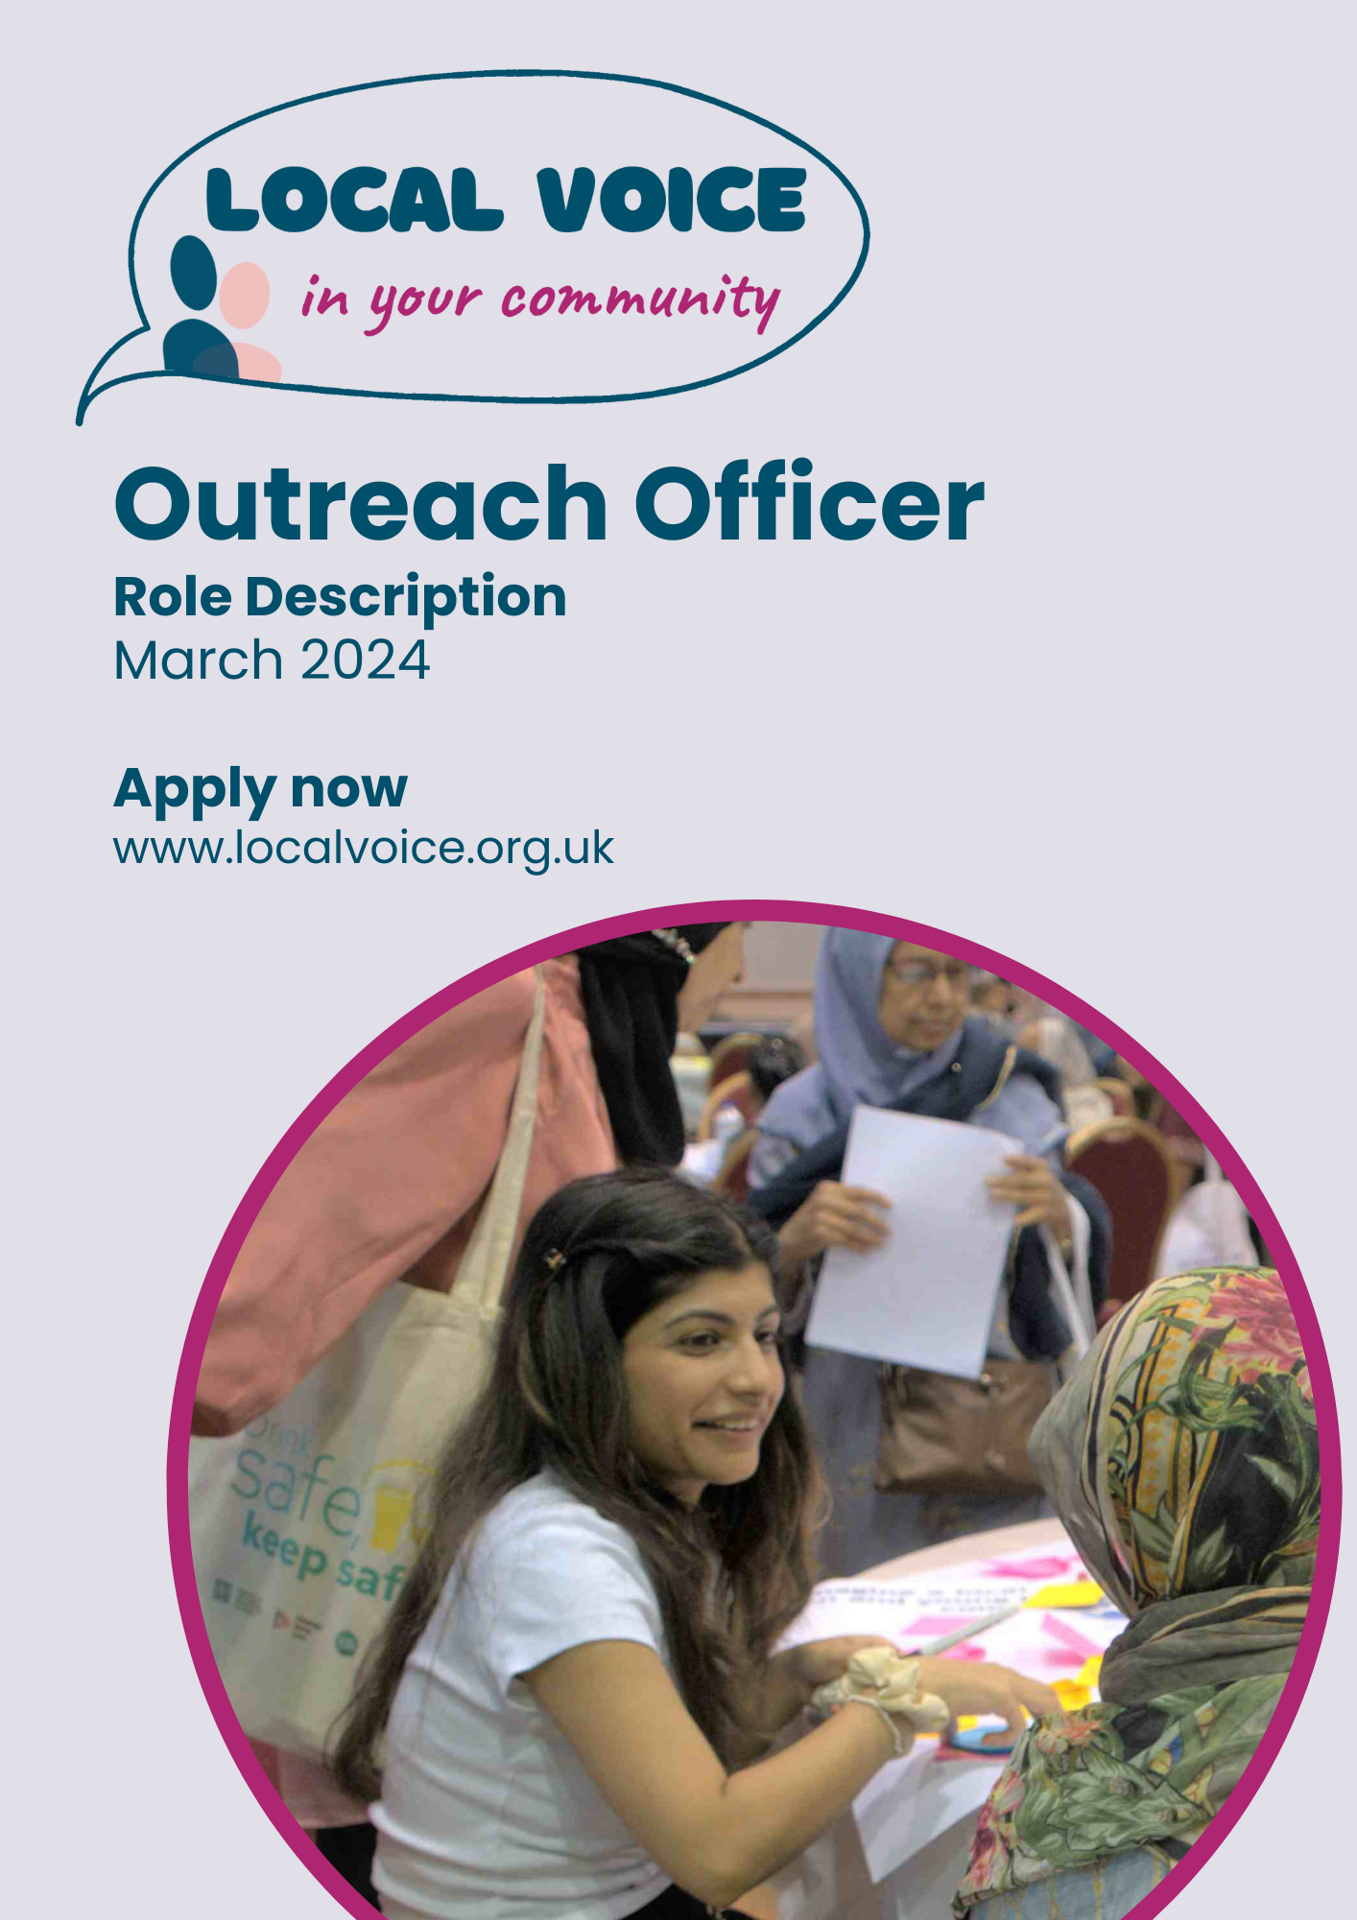

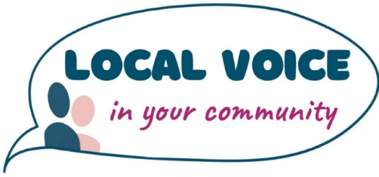
Outreach Officer Role
Commitment: 2 days (14 hours) per week
Payment: £15 per hour

ABOUT LOCAL VOICE
Local Voice is the first user-led organisation to engage and support resident voice through a recognised evidence-based community insights data system.
We provide:
- Data solutions, management, and partnerships for local Healthwatch.
- Community intelligence and insights reporting to inform quality improvement and service co-production.
- Training and e-learning resources to support staff and organisations to better understand and utilise resident and user voice to design and improve services.
We are also currently the organisation running Healthwatch Waltham Forest.
About Healthwatch Waltham Forest
The role of Healthwatch is to:

- Promote and support the involvement of local people in the commissioning, provision, and scrutiny of local care services.
- Enable local people to monitor the standard of provision of local care services and how services could be improved.
- Obtain the views of local people regarding their needs for, and experiences of, local care services and make these views known.
- Make reports and recommendations about how local care services could be improved.
- Provide information about local health and social care services to the public.
- Formulate views on the standard of provision and whether and how the local care services could be improved.
- Make recommendations to Healthwatch England to advise the Care Quality Commission to conduct special reviews or investigations.
- Provide Healthwatch England with the intelligence and insight it needs to enable it to perform effectively.
MAIN RESPONSIBILITIES
Outreach
Your role will be to deliver a programme of outreach and engagement activities across the community to:
- gather feedback from local people on their experience of health and social care services;
- provide local residents with information and signposting to enable them to access health and care services; and
- promote Healthwatch Waltham Forest and actively encourage local people to get involved in the work that we do.
This will be achieved through:
- face to face engagement at:
  - service provider premises (hospitals, GP Practices, care homes);
  - community venues (shopping centres, libraries, leisure centres);
  - community events (community and faith groups, festivals, fun days);
  - targeted engagement (focus groups, listening events and case studies) and at meetings.
- through working with voluntary, community and faith organisations to reach seldom heard groups in the community such as children and young people, the white working class, the homeless and people with a learning disability;
- through supporting enter and view visits to service providers;
- expanding our online feedback mechanisms and use of social media platforms to gather intelligence.
- providing reports from outreach activities evaluating the mechanisms used, the quantity and quality of the feedback gathered.
Information and signposting
Your role will be to:
- act as a point of contact for information and signposting enquiries by in person by local residents;
- record the details of enquiries, including follow-up provided and input them into the Healthwatch Community Insights System;
- develop a knowledge of:
- sources of information on health and care services and how residents / service users / carers can access this information including online and links to external personnel;
- key online directories of health and social care services and be able to confidently guide local people through their use;
- voluntary and community sector information and advocacy support providers and signpost residents appropriately.
- train and support volunteers to carry out information and signposting;
- provide reports on the nature of the signposting activity, identify gaps in information relating to health and social care services, suggestions for information improvement.
Data recording
Your role will be to:
- enter data gathered through the outreach and engagement programme on the Healthwatch Community Insights System database;
- supervise volunteers data entry onto the Healthwatch database ensuring that all data entries are accurate, correctly spelled, and grammatically correct and error free;
- adhere to data protection standards as appropriate;
- ensure data filing and recording systems both electronic and paper based are maintained effectively and comply with Healthwatch Tower Hamlets Board Data Protection Policy.
Partnership working:
Your role will be to:
- liaise with other local Healthwatch to identify best practice in engagement, information gathering, publicity and volunteer recruitment and support;
- work collaboratively with other local Healthwatch organisations where appropriate.
Person Specification

Experience of:
- conducting engagement and outreach activities and planning and organising events (Essential (E));
- interviewing, answering enquiries from and providing advice to members of the public face to face, over the phone or online (E);
- working with volunteers and designing and developing volunteer programmes (Desirable (D));
- working with a range of stakeholders, including hard-to-engage communities, local government, healthcare providers and voluntary sector organisations (D);
- liaising with providers of information on health and social care issues (D);
A good working knowledge of:
- methods and channels for engaging with a wide range of communities from a variety of backgrounds (E);
- Microsoft office software including Word, Excel, PowerPoint, and Access and ability to learn skills quickly (E);
- the health and social care system and/or community engagement (D);
- the voluntary and not-for-profit sectors (D).
Skills
- Excellent communication skills, both oral and written, and the ability to engage and build relationships with a range of stakeholders (E);
- Strong organisational and planning skills, the ability to prioritise in the face of competing demands, and proven success in delivering work personally (E);
- Ability to use ICT effectively for communications and information management (E);
- Ability to build and sustain strong working relationships with volunteers (E);
- Ability to link volunteering activities with organisational strategy (E).
Qualifications
- Educated to degree level or equivalent (D).
You must show a commitment to:
- work with residents, service users and patients to bring about change;
- detail, ensuring all work is accurate, concise and understandable;
- equality and diversity and to providing accessible communications and opportunities to engage;
- undertake any personal training that may be required to keep up-to-date and fulfil the requirements identified for this job description and make full use of line management and supervision;
- attend meetings, conferences and events, representing Healthwatch as required;
- participate in Healthwatch Waltham Forest team meetings, staff development, away days and reviews;
- acquiring a good working knowledge of other agencies and initiatives of relevance to the Healthwatch Waltham Forest programme in its relations with service users;
- take responsibility for your own health and safety and that of others affected by Healthwatch Waltham Forests operations;

- maintain the security and confidentiality of data and information handled by Healthwatch Waltham Forests.

Other requirements
- Evening/week-end meetings when required (for which time off in lieu will be given) and travel across and outside the Borough.
- Legally work in the UK.
- The post is subject to an enhanced DBS disclosure.

It is the nature of the work of Healthwatch Waltham Forest and Local Voice that tasks and responsibilities are, in many circumstances, unpredictable and varied. All employees are therefore required to work in a flexible way when the occasion arises, so that tasks not specifically covered in the job description are undertaken. These additional duties will normally be compatible with the skills and responsibility of the existing work.

Important Information:

The deadline for completed applications is:
12 noon on Friday 24 May 2024
Please send your completed application form to info@localvoice.org.uk

If you would like to discuss the role please contact Dianne Barham on 07880551559

A competency based test prior to interview will form part of the interview process

