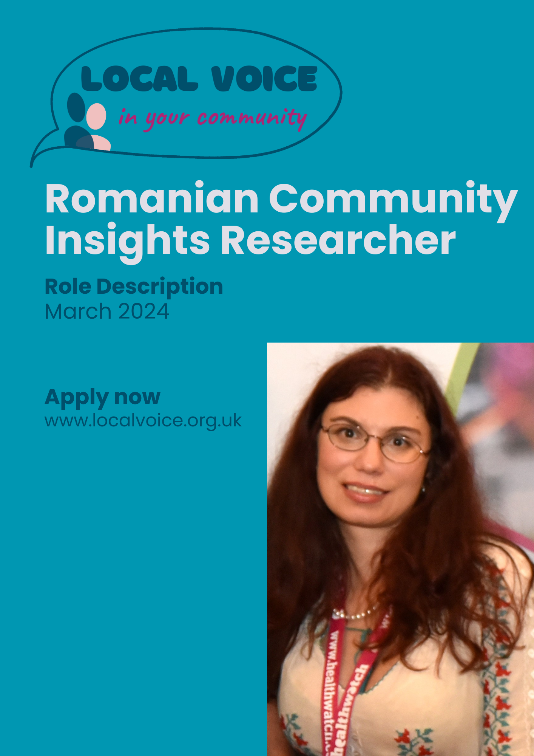

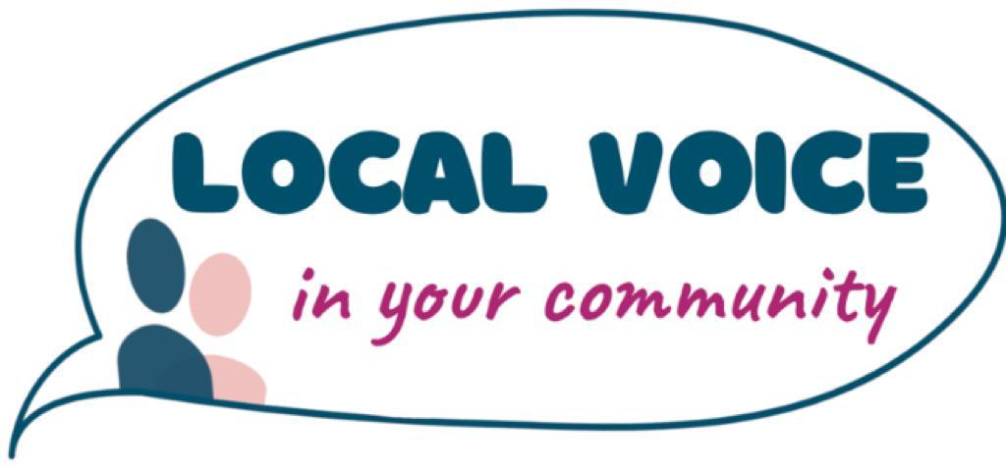

Romanian Community Insights Researcher Role
Commitment: 2-6 hours per week
Payment: £13.15 per hour
This is a temporary post based on delivering a Romanian focused community insights project however there is the potential for further sessional work as a general Community Insights Researcher.
ABOUT LOCAL VOICE
Local Voice is the first user-led organisation to engage and support resident voice through a recognised evidence-based community insights data system.
We provide:
- Data solutions, management, and partnerships for local Healthwatch.
- Community intelligence and insights reporting to inform quality improvement and service co-production.
- Training and e-learning resources to support staff and organisations to better understand and utilise resident and user voice to design and improve services.
We are also currently the organisation running Healthwatch Waltham Forest
ABOUT HEALTHWATCH
The role of Healthwatch is to:
- Promote and support the involvement of local people in the commissioning, provision and scrutiny of local care services.
- Enable local people to monitor the standard of provision of local care services and how services could be improved.
- Obtain the views of local people regarding their needs for, and experiences of, local care services and make these views known.
- Make reports and recommendations about how local care services could be improved.
- Provide information about local health and social care services to the public.
- Formulate views on the standard of provision and whether and how the local care services could be improved.
- Make recommendations to Healthwatch England to advise the Care Quality Commission to conduct special reviews or investigations.
- Provide Healthwatch England with the intelligence and insight it needs to enable it to perform effectively.
Community Insight Researcher Role
The role is to support the gathering of community insights and the collation and maintenance of a database of evidence of Romanian resident, service user and patient views on health and social care services.
Main Activities:
- Record local Romanian peoples experiences of health and care services and enter the insights gathered into the Local Voice Community Insights System Mircrosoft Access database.
- Conduct indepth interviews surveys and paritipatory apprasial programme activities (over the phone, online and face to face) with local Romanian people.
- Work with Local Voice staff members across Waltham Forest and Newham to support the organisation and delivery of engagement activities that reach local Romanian people.
- Undertake qualitative and quantitative data analysis, reporting and research, including:
- Conducting surveys/focus groups; pretesting research instruments and providing the Head of Intelligence and Insights with feedback.
- Coding and theming qualitative data, using software such as Dedoose or Taguette.
- Assisting in the organisation of stakeholder events and public consultation meetings, workshops and seminars aimed at Romanian communities.
- maintaining the security and confidentiality of data and information handled by the local Healthwatch and Local Voice and follow ethical protocols at all times.

Responsibilities
- Undertake an initial short participatory research training course.
- Have due regard to the charity’s data protection and confidentiality policies.
- Attend online networking events, project briefings and team meetings as required.

Person specification
Experience of:
- using technology and computer software including Access, Microsoft Office, Excel, and PowerPoint;
- applied research, including conducting surveys and interviews and in group facilitation;
- community engagement, working with diverse communities and or third sector;
- working with local residents or service user/patient representatives.
A good working knowledge of:
- relevant research methods and techniques;
- data collection and data analysis techniques.
- community engagement and participation principles and techniques.

Skills
- data collection, analysis and reporting skills;
- interpersonal skills necessary to work effectively with research stakeholders and a wide range of people and diverse groups;
- strong creative and critical thinking and problem solving skills;
- Well-organised and detail oriented;
Qualifications
- Educated to degree level or currently in university education.

Competencies
- Ability to speak Romanian fluentely;
- Commitment to working with residents, service users and patients to bring about change and to using research to bring about equality of opportunity;
- Able to work independently and as part of a small team in a challenging, fast paced environment;
- Take part in training and personal development and participate in team meetings, staff development, away days and reviews;
- Able to take responsibility for own health and safety and that of others affected by Local Voice operations;
- High personal standards for integrity, accuracy and clarity;
- To ensure that issues of equality and diversity are considered integral to Healthwatch activities and communications.

It is the nature of the work of Local Voice that tasks and responsibilities are, in many circumstances, unpredictable and varied. All employees are therefore required to work in a flexible way when the occasion arises, so that tasks not specifically covered in the job description are undertaken. These additional duties will normally be compatible with the skills and responsibility of the existing work.
You must also be able to:
- Work evening/week-end meetings occasionally when required
- Legally work in the UK

This is a zero hours contract.

